Difference between CSMA CA and CSMA CD

**CSMA** is a mechanism that senses the state of the shared channel to prevent or recover data packets from a collision. It is also used to control the flow of data packets over the network so that the packets are not get lost, and data integrity is maintained. In CSMA, when two or more data packets are sent at the same time on a shared channel, the chances of collision occurred. Due to the collision, the receiver does not get any information regarding the sender's data packets. And the lost information needs to be resented so that the receiver can get it. Therefore we need to sense the channel before transmitting data packets on a network. It is divided into two parts, **CSMA CA** (Collision Avoidance) and **CSMA CD** (Collision Detection).

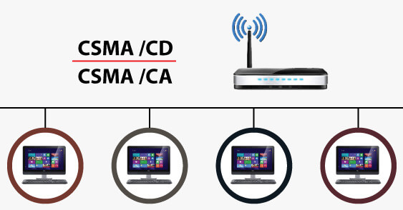

CSMA CD

The **Carrier Sense Multiple Access/ Collision Detection** protocol is used to detect a collision in the media access control (**MAC**) layer. Once the collision was detected, the CSMA CD immediately stopped the transmission by sending the signal so that the sender does not waste all the time to send the data packet. Suppose a collision is detected from each station while broadcasting the packets. In that case, the CSMA CD immediately sends a jam signal to stop transmission and waits for a random time context before transmitting another data packet. If the channel is found free, it immediately sends the data and returns it.

Advantage and Disadvantage of CSMA CD

**Advantages of CSMA CD:**

1. It is used for collision detection on a shared channel within a very short time.
2. CSMA CD is better than CSMA for collision detection.
3. CSMA CD is used to avoid any form of waste transmission.
4. When necessary, it is used to use or share the same amount of bandwidth at each station.
5. It has lower CSMA CD overhead as compared to the CSMA CA.

**Disadvantage of CSMA CD**

1. It is not suitable for long-distance networks because as the distance increases, CSMA CD' efficiency decreases.
2. It can detect collision only up to 2500 meters, and beyond this range, it cannot detect collisions.
3. When multiple devices are added to a CSMA CD, collision detection performance is reduced.

CSMA/CA

CSMA stands for **Carrier Sense Multiple Access** with **Collision Avoidance**. It means that it is a network protocol that uses to avoid a collision rather than allowing it to occur, and it does not deal with the recovery of packets after a collision. It is similar to the CSMA CD protocol that operates in the media access control layer. In CSMA CA, whenever a station sends a data frame to a channel, it checks whether it is in use. If the shared channel is busy, the station waits until the channel enters idle mode. Hence, we can say that it reduces the chances of collisions and makes better use of the medium to send data packets more efficiently.

Advantage and Disadvantage of CSMA CA

**Advantage of CSMA CA**

1. When the size of data packets is large, the chances of collision in CSMA CA is less.
2. It controls the data packets and sends the data when the receiver wants to send them.
3. It is used to prevent collision rather than collision detection on the shared channel.
4. CSMA CA avoids wasted transmission of data over the channel.
5. It is best suited for wireless transmission in a network.
6. It avoids unnecessary data traffic on the network with the help of the RTS/ CTS extension.

**The disadvantage of CSMA CA**

1. Sometime CSMA/CA takes much waiting time as usual to transmit the data packet.
2. It consumes more bandwidth by each station.
3. Its efficiency is less than a CSMA CD.

Difference between CSMA CA and CSMA CD

|  |  |  |
| --- | --- | --- |
| **S. No** | **CSMA CD** | **CSMA CA** |
| 1. | It is the type of CSMA to detect the collision on a shared channel. | It is the type of CSMA to avoid collision on a shared channel. |
| 2. | It is the collision detection protocol. | It is the collision avoidance protocol. |
| 3. | It is used in 802.3 Ethernet network cable. | It is used in the 802.11 Ethernet network. |
| 4. | It works in wired networks. | It works in wireless networks. |
| 5. | It is effective after collision detection on a network. | It is effective before collision detection on a network. |
| 6. | Whenever a data packet conflicts in a shared channel, it resends the data frame. | Whereas the CSMA CA waits until the channel is busy and does not recover after a collision. |
| 7. | It minimizes the recovery time. | It minimizes the risk of collision. |
| 8. | The efficiency of CSMA CD is high as compared to CSMA. | The efficiency of CSMA CA is similar to CSMA. |
| 9. | It is more popular than the CSMA CA protocol. | It is less popular than CSMA CD. |